# ScrumAge Rules

### Written by Jimmy Parker

## Initial startup

Budget = 12

Starting pawns = 2 front end, 3 back end, 0 full stack developers

Starting resources:

* Wood: 20
* Brick: 16
* Stone: 12
* Gold: 10

### Resource Allocation

Amount of pawns available at location:

* Training hut: 1
* Baby hut: 2 (must be from same player)
* Agriculture hut (fields): 1
* Resource spaces (wood, clay, etc): up to 7 slots each
* Buildings (per card) 4 stacks 7 cards each: 1 slot each stack
* Civilization cards (per card) 4 stacks each: 1 slot each stack

### How to end the game

Round limit of 4 sprints, once finished during the action phase it then proceeds to feeding then scoring to finish the game.

### How to resolve player actions

Player may resolve actions at any location in any order once all players have finished placing their pawns.

#### Locations

Training hut: Increase a front end or back end dev to a full stack

Hut: Take another pawn and add to your total, this will increase need for food during feeding phase.

Field (agricultural hut): Move food track 1 space forward requiring less food each turn during feeding phase.

Hunt: For each pawn at the hunting field a player takes 1 die. When rolled divide the result by two rounding down to get that amount of food.

Resources: for each pawn at field a player rolls 1 die. Once result is added up divide by number below to gain that many resources:

* Wood: 3
* Clay: 4
* Stone: 5
* Gold: 6

Civilization cards:

* Requires at least 1 of each resource
* Types of civilization cards:
  + Dice roll:
    - Roll number of dice = # of players, resolve the dice with the values on cards:
      * 6=ag level+1, 5=tool level+1, 4=gold+1, 3=stone+1, 2=brick+1, 1=wood+1
      * Resolve this in player order, (ie clockwise)
    - Roll 2 dice, resolve as you would during action phase per resource on card.
  + Some cards have other types of resources that are used when scoring such as:
    - Builder
    - Farmer
    - Tool maker
    - Shaman
  + Food
    - Civ cards with a random number of food from 7-2 food along with other additions such as builders or farmers.
  + Resources
    - Player immediately takes the resource shown on the card from the supply
      * 1 stone, 2 stone, 1 stone, 1 gold, 1 brick
      * Includes farmer, shaman or transport along with resource
  + Additional tool
    - Increase score by 5, ***not implementing tools***
  + 2 resources of player’s choice
    - Once obtained the player is able to have a one-time use where the card is exchanged for 2 resources (does not have to be the same type) The card then is no longer usable.
* Building Tiles
  + Require up to 3 resources for victory points.
  + Cards in game:

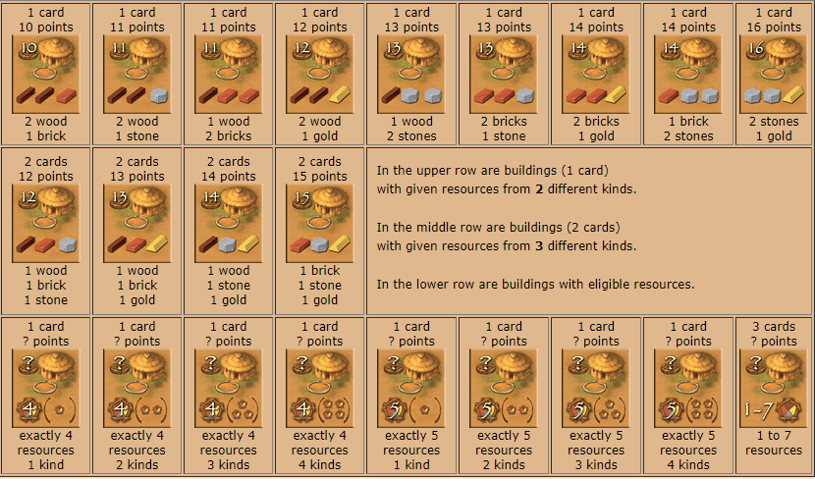

### Feeding Rules

During the feeding phase each player will take the amount of fund production from their budget (ag level) and add it to the current funds.

During the feeding phase we will subtract the amount of current funds determined by back/front end = 1 fund and full stack = 2 fund, if the player does not have the appropriate funds then the player will lose all available funds and a random dev.

If insufficient funds and lack of resources the player, then loses 10 score (feature not in the budget).

### Misc rules

Player is not allowed to pass a turn. If there are currently places available to for a player to place pawn they must place it on their turn.

A tool can only be used once per round. Tool level counts as number of tools (ie. Level 4 tool can use a tool 4 times. Use 3 tools to gather wood and use 1 tool to gather clay.)

If players are not able/don’t want to pay for a building tile they are currently on they are removed from the tile not activating it/taking it.

Resolve civ cards/building tiles victory point additions as they are resolved during the action phase. Ie if a card is paid for resolve the addition to resources, points, etc. at the same time. This may be influential in their next step during their remaining action resolutions.

### Scoring

Civilization Cards:

1. Green background: multiply by number of green cards
2. Sand background:

a) Multiply # of farmers on card by position of player’s marker on food track

b) Multiply # of tool makers on card by value of player’s tools

c) Multiply # of builders on card by # of buildings

d) Multiply of developers by shaman (documentation)

Bonus points per building card, added as game progresses.

Bonus points per number of pawns.

Front end/back end programmers = 1

Full stack developers = 2